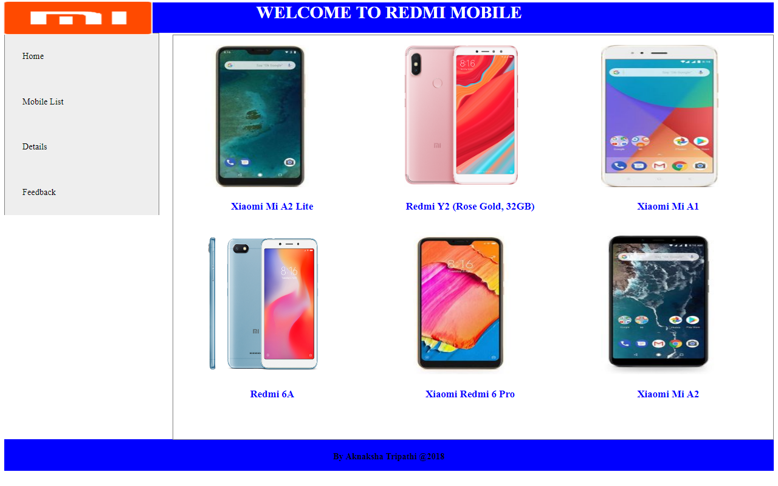

<!DOCTYPE html>
<html>
<head>
<meta name="viewport" content="width=device-width, initial-scale=1">
<style>
/*h1{color:red}
h2{color:blue}
right{color:red}
* {box-sizing: border-box}
body {font-family: "Lato", sans-serif;}

/* Style the tab */
/*.tab {
float: left;
border: 2px solid #ccc;
background-color: #f1f1f1;
width: 30%;
height: 300px;
}*/

/* Style the buttons inside the tab */
/*.tab button {
display: block;
background-color: lemon green;
color: blue;
padding: 22px 16px;
width: 100%;
border: none;
outline: none;
text-align: left;
cursor: pointer;
transition: 0.3s;
font-size: 17px;
}
*/
/* Change background color of buttons on hover */
/*.tab button:hover {
background-color: white;
}*/

/* Create an active/current "tab button" class */
/*.tab button.active {
background-color: grey;
}*/

/* Style the tab content */
/*.tabcontent {
float: left;
padding: 0px 12px;
border: 2px solid #ccc;
width: 70%;
border-left: none;
height: 300px;
}*/
img{
height: 260px;
width: 214px;
margin-left: 4px;
/* margin: 0px auto; */
margin-top: 15px;
padding: 2px 55px;
}

.right
{
width: 78%;
float: right;
margin-top: -330px;
border: 1px solid gray;
/* height: 200px; */
height: 739px;
}
.vertical-menu {
max-width: 20%;
border: 1px solid gray;
}

.vertical-menu a {

background-color: #eee;
color: black;
display: block;
padding: 32px;
text-decoration: none;

}

.vertical-menu a:hover {
background-color: #ccc;
}

.vertical-menu a.active {
background-color: #4CAF50;
color: white;
}
</style>
</head>
<body>
<div style="margin: 0 auto;
height: 839px; margin-top: -44px;">
<img src="redmi.png" style="height: 61px;
margin-bottom: -87px;
width: 274px;
margin-left: -58px;" />
<center>
<div style="color: white; background-color: blue;
height: 56px;"><h1>WELCOME TO REDMI MOBILE</h1></div>
<!-- <h2>All of you are welcomed by Radmi:</h2> -->
</center>
<!-- <div class="tab">
<a href="mi.html" class="tablinks" onclick="(event, 'HOME')" id="defaultOpen">HOME</a>
<button class="tablinks" onclick="(event, 'MOBILE LIST')">MOBILE LIST</button>
<button class="tablinks" onclick="(event, 'DETAIL')">DETAIL</button>
<button class="tablinks" onclick="(event, 'FEEDBACK')" id="defaultOpen">FEEDBACK</button>
<a href="" class="tablinks">Home</a>
<a href="ml.html" class="tablinks">MOBILE LIST</a>
</div> -->

<div class="vertical-menu">
<a href="mi.html" onclick="active">Home</a>
<a href="Mobile_list.html" onclick="active">Mobile List</a>
<a href="details.html" onclick="active">Details</a>
<a href="Feedbaack.html" onclick="active">Feedback</a>
<!-- <a href="#">Link 4</a> -->
</div>

<div class="right">
<div style="width:33%; float: left;">
<img src="xiaomi-mi-a2-lite.jpg"/>
<h3 style="text-align: center; color: blue;">Xiaomi Mi A2 Lite</h3>
</div>

<div style="width:33%; float: left;">
<img src="r4.png"/>
<h3 style="text-align: center; color: blue;">Redmi Y2 (Rose Gold, 32GB)</h3>
</div>
<div style="width:33%; float: left;">
<img src="xiaomi-mi-a1.jpg"/>
<h3 style="text-align: center; color: blue;">Xiaomi Mi A1</h3>
</div>
<div style="width:33%; float: left;">
<img src="Redmi 6A .jpg"/>
<h3 style="text-align: center; color: blue;">Redmi 6A</h3>
</div>
<div style="width:33%; float: left;">
<img src="xiaomi-redmi-6-pro.jpg"/>
<h3 style="text-align: center; color: blue;">Xiaomi Redmi 6 Pro</h3>
</div>
<div style="width:33%; float: left;">
<img src="xiaomi-mi-a2.jpg"/>
<h3 style="text-align: center; color: blue;">Xiaomi Mi A2
</h3>
</div>
</div>
</div>
<footer style="background-color: blue;
height: 42px;

text-align: center;
padding: 1px 0px 15px;;">
<h4>By Akanksha Tripathi @2018</h4>
</footer>
</body>
</html>

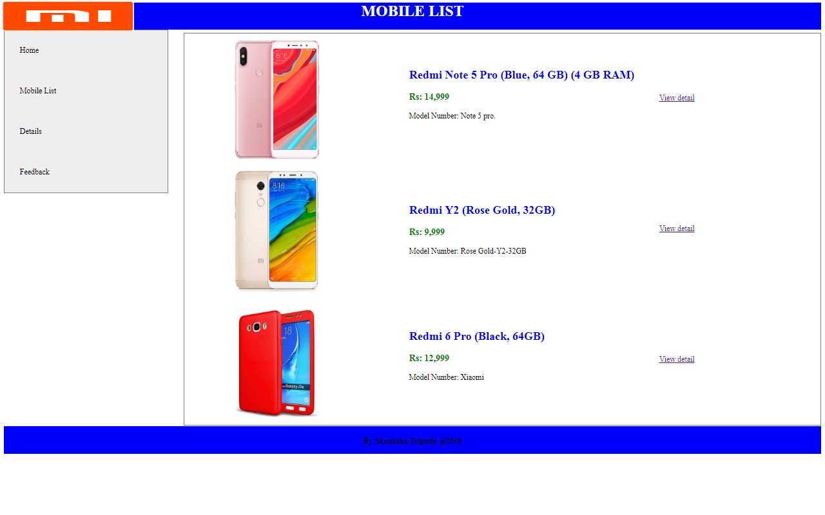

<!DOCTYPE html>
<html>
<head>
<meta name="viewport" content="width=device-width, initial-scale=1">
<style>
img {
margin-left: -77px;
/* margin-bottom: 30px; */
margin-top: 13px;
height: 251px;
}
.right
{
width: 78%;
float: right;
margin-top: -331px;
border: 1px solid gray;
/* height: 200px; */
height: 733px;
}
.vertical-menu {
max-width: 20%;
border: 1px solid gray;
}

.vertical-menu a {

background-color: #eee;
color: black;
display: block;
padding: 32px;
text-decoration: none;

}

.vertical-menu a:hover {
background-color: #ccc;
}

.vertical-menu a.active {
background-color: #4CAF50;
color: white;
}

</style>
</head>
<body>
<div style="margin: 0 auto;
height: 918px; margin-top: -44px;">
<img src="redmi.png" style="height: 61px;
margin-bottom: -85px;
width: 273px;
margin-left: -4px;" />
<center>
<div style="color: white; background-color: blue;
height: 56px;"><h1>MOBILE LIST</h1></div>
<!-- <h2>All of you are welcomed by Radmi:</h2> -->
</center>
<div class="vertical-menu">
<a href="mi.html" onclick="active">Home</a>
<a href="Mobile_list.html" onclick="active">Mobile List</a>
<a href="details.html" onclick="active">Details</a>
<a href="Feedbaack.html" onclick="active">Feedback</a>
<!-- <a href="#">Link 4</a> -->
</div>
<table class="right">
<tr>
<td align="center"><img src="r4.png" width="180" lenght="90"/></td>
<td style="width: 515px;"><h2 style="color: blue;">Redmi Note 5 Pro (Blue, 64 GB) (4 GB RAM)</h2>

<h3 style="color: green;">Rs: 14,999</h3>
<p>
Model Number: Note 5 pro.<br/>
<br/>
</p>
</td>
<td><a href="details.html">View detail</html></td>
</tr>
<tr>
<td align="center"><img src="r5.png" width="180" lenght="90"/></td>
<td><h2 style="color: blue;">Redmi Y2 (Rose Gold, 32GB)</h2>
<h3 style="color: green;">Rs: 9,999</h3>
<p>
Model Number: Rose Gold-Y2-32GB<br/>
</p>
</td>
<td><a href="details.html">View detail</html></td>
</tr>
<tr>
<td align="center"><img src="r6.png" width="180" lenght="90"/></td>
<td><h2 style="color: blue;">Redmi 6 Pro (Black, 64GB)</h2>
<h3 style="color: green;">Rs: 12,999</h3>
<p>
Model Number: Xiaomi<br/>
<br/>
</p>
</td>
<td><a href="details.html">View detail</html></td>
</tr>
</table>
</div>
<footer style="background-color: blue;
height: 42px;

text-align: center;
padding: 1px 0px 15px;">
<h4>By Aknaksha Tripathi @2018</h4>
</footer>
</body>
</html>

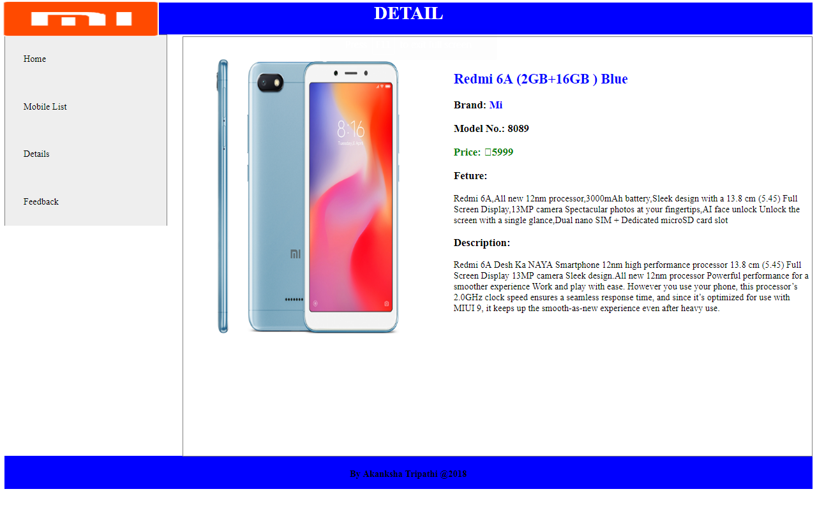<!DOCTYPE html>
<html>
<head>
<meta name="viewport" content="width=device-width, initial-scale=1">
<style>
img {
margin-left: -31px;
/* margin-bottom: 30px; */
margin-top: -170px;
height: 514px;
width: 339px;
}
.right
{
width: 78%;
float: right;
margin-top: -331px;
border: 1px solid gray;
/* height: 200px; */
height: 733px;
}
.vertical-menu {
max-width: 20%;
border: 1px solid gray;
}

.vertical-menu a {

background-color: #eee;
color: black;
display: block;
padding: 32px;
text-decoration: none;

}

.vertical-menu a:hover {
background-color: #ccc;
}

.vertical-menu a.active {
background-color: #4CAF50;
color: white;
}

</style>
</head>
<body>
<div style="margin: 0 auto;
height: 830px; margin-top: -44px;">
<img src="redmi.png" style="height: 61px;
margin-bottom: -85px;
width: 273px;
margin-left: -4px;" />
<center>
<div style="color: white; background-color: blue;
height: 56px;"><h1>DETAIL </h1></div>
<!-- <h2>All of you are welcomed by Radmi:</h2> -->
</center>
<div class="vertical-menu">
<a href="mi.html" onclick="active">Home</a>
<a href="Mobile_list.html" onclick="active">Mobile List</a>
<a href="details.html" onclick="active">Details</a>
<a href="Feedbaack.html" onclick="active">Feedback</a>
<!-- <a href="#">Link 4</a> -->
</div>
<table class="right">
<tr>
<td align="center" style="width: 225px;"><img src="Redmi 6A .jpg" width="180" lenght="90"/></td>
<td style="width: 410px; padding-bottom: 205px;"><h2 style="color: blue">Redmi 6A (2GB+16GB ) Blue</h2>
<h3>Brand: <span style="color: blue;">Mi</span></h3>
<h3>Model No.: 8089</h3>
<h3 style="color: green;">Price: â‚¹5999</h3>
<p><h3>Feture: </h3> Redmi 6A,All new 12nm processor,3000mAh battery,Sleek design with a 13.8 cm (5.45) Full Screen Display,13MP camera Spectacular photos at your fingertips,AI face unlock Unlock the screen with a single glance,Dual nano SIM + Dedicated microSD card slot </p>
<p><h3>Description:</h3></strong>
Redmi 6A Desh Ka NAYA Smartphone 12nm high performance processor 13.8 cm (5.45) Full Screen Display 13MP camera Sleek design.All new 12nm processor Powerful performance for a smoother experience Work and play with ease. However you use your phone, this processorâ€™s 2.0GHz clock speed ensures a seamless response time, and since itâ€™s optimized for use with MIUI 9, it keeps up the smooth-as-new experience even after heavy use.

</table>
</div>
<footer style="background-color: blue;
height: 42px;

text-align: center;
padding: 1px 0px 15px;">
<h4>By Akanksha Tripathi @2018</h4>
</footer>
</body>
</html>

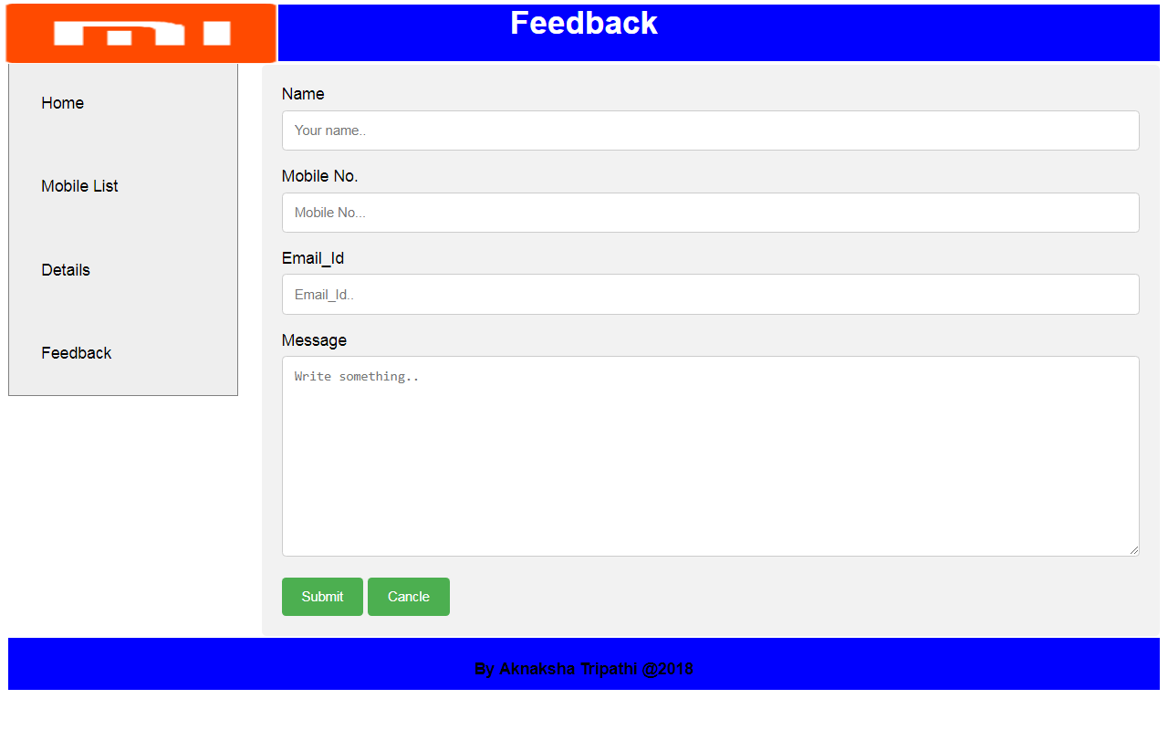<!DOCTYPE html>
<html>
<head>
<meta name="viewport" content="width=device-width, initial-scale=1">
<style>
body {font-family: Arial, Helvetica, sans-serif;}
* {box-sizing: border-box;}

input[type=text], select, textarea {
width: 100%;
padding: 12px;
border: 1px solid #ccc;
border-radius: 4px;
box-sizing: border-box;
margin-top: 6px;
margin-bottom: 16px;
resize: vertical;
}
input[type=number], select, textarea {
width: 100%;
padding: 12px;
border: 1px solid #ccc;
border-radius: 4px;
box-sizing: border-box;
margin-top: 6px;
margin-bottom: 16px;
resize: vertical;
}
input[type=email], select, textarea {
width: 100%;
padding: 12px;
border: 1px solid #ccc;
border-radius: 4px;
box-sizing: border-box;
margin-top: 6px;
margin-bottom: 16px;
resize: vertical;
}

input[type=submit] {
background-color: #4CAF50;
color: white;
padding: 12px 20px;
border: none;
border-radius: 4px;
cursor: pointer;
}
input[type=button] {
background-color: #4CAF50;
color: white;
padding: 12px 20px;
border: none;
border-radius: 4px;
cursor: pointer;
}
input[type=button]:hover {
background-color: #45a049;
}
input[type=submit]:hover {
background-color: #45a049;
}
.right{
margin: 0 auto;
width: 78%;
float: right;
margin-top: -330px;
}
.container {
border-radius: 5px;
background-color: #f2f2f2;
padding: 20px;
}
.vertical-menu {
max-width: 20%;
border: 1px solid gray;
}

.vertical-menu a {

background-color: #eee;
color: black;
display: block;
padding: 32px;
text-decoration: none;

}

.vertical-menu a:hover {
background-color: #ccc;
}

.vertical-menu a.active {
background-color: #4CAF50;
color: white;
}
</style>
</head>
<body>
<div style="margin: 0 auto;
height: 671px; margin-top: -44px;">
<img src="redmi.png" style="height: 61px;
margin-bottom: -85px;
width: 273px;
margin-left: -4px;" />
<center>
<div style="color: white; background-color: blue;
height: 56px;"><h1>Feedback</h1></div>
<!-- <h2>All of you are welcomed by Radmi:</h2> -->
</center>
<div class="vertical-menu">
<a href="mi.html" onclick="active">Home</a>
<a href="Mobile_list.html" onclick="active">Mobile List</a>
<a href="details.html" onclick="active">Details</a>
<a href="Feedbaack.html" onclick="active">Feedback</a>
<!-- <a href="#">Link 4</a> -->
</div>
<div class="container right">
<form id="myForm">
<label for="yname">Name</label>
<input type="text" id="yname" required placeholder="Your name..">

<label for="mobileno">Mobile No.</label>
<input type="number" id="mobileno" required placeholder="Mobile No...">

<label for="Email">Email_Id</label>
<input type="email" id="Email" required placeholder="Email_Id..">

<!-- <label for="country">Country</label>
<select id="country" name="country">
<option value="australia">Australia</option>
<option value="canada">Canada</option>
<option value="usa">USA</option>
</select> -->

<label for="message">Message</label>
<textarea id="message" name="message" placeholder="Write something.." style="height:200px"></textarea>
<input type="submit" value="Submit">
<input type="button" onclick="myFunction()" value="Cancle">
</form>
</div>
</div>
<footer style="background-color: blue;
height: 42px;

text-align: center;
padding: 1px 0px 51px;">
<h4>By Akanksha Tripathi @2018</h4>
</footer>
</body>
<script>
function myFunction() {
document.getElementById("myForm").reset();
}
</script>
</html>

